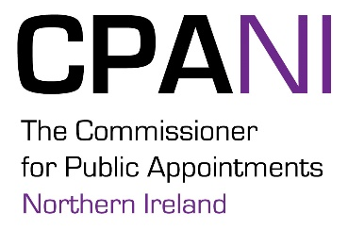
Guidance where an applicant is known to a member of a selection panel

This guidance is intended to assist Departments and selection panels to deal with a situation where an applicant for a public appointment is known to a member of a selection panel. Paragraph 3.38 of the Code of Practice tasks the selection panel to ensure that integrity and issues of conflict of interest have been both explained to and explored fully and robustly with any applicant. It is therefore essential that the same standards are met by selection panel members.
Departments will ensure that all selection panel members declare any conflicts of interest that may be relevant to their participation as panel members. This is particularly pertinent where panel members know applicants. In such cases the panel member will disclose the nature and extent of the relationship or knowledge of the applicant. Generally speaking in instances where a selection panel member knows an applicant the responsibility for dealing with this will sit with the Chair of the panel who will ensure that the matter is dealt with in an open and proportionate manner to protect the integrity of the process. Where the issue relates to the Chair then the matter should be dealt with by the selection panel as a whole. No panel member is to be kept in the dark about such issues, unless the matter is genuinely of such a personal nature that it would cause grave embarrassment if shared. Knowledge of an applicant does not automatically represent a conflict of interest, however the panel must ensure that the issue is openly discussed and properly recorded.
Where the panel decides that no conflict of interest exists then the background, the discussions held and the decision should be recorded.
Where such a relationship is judged significant enough to have an impact on the outcome of the process or the public perception of the outcome, or where the panel considers that it represents an unmanageable conflict of interest and that it could be perceived that the panel member would be unable to provide totally impartial assessment of the applicant, then the option is open for the panel member to recuse themselves from the assessment of that applicant. This would be a last resort.
Applicants may also request the recusal of a panel member if the circumstances merit it. Such a request will be discussed, and decided upon in an open, proportionate and timely manner by the whole selection panel.
The Northern Ireland Audit Office (NIAO) has also published good practice guidance on conflicts of interest which is available from the NIAO website.

